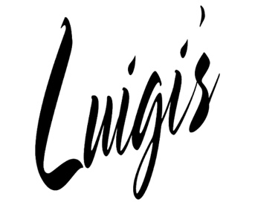
170 Post Road, Fairfield · 203.259.7816 · luigisfairfield.com

ON-SITE FUNCTION MENU
FAMILY STYLE APPETIZERS (pick three)
Antipasto
Caprese Salad
Bruschetta
Stuffed Mushrooms
Fried Calamari

SALAD (pick one)
House Salad
Caesar Salad

ENTREES (pick three)
Stuffed Rigatoni – Rigatoni filled with assorted cheeses and topped with vodka sauce
Eggplant Rollatini – Stuffed with ricotta cheese and spinach
Chicken Piccata – Chicken breast sautéed with lemon and butter
Chicken Marsala – Chicken breast sautéed with mushrooms and Marsala wine
Chicken Parmigiana – Breaded chicken breast topped with tomato sauce and mozzarella
Sausage and Peppers
Costoletta di Maiale – Pork chop or pork loin sautéed with potatoes, sweet vinegar peppers, caramelized onions, fresh rosemary
Grouper al Vino e Limone – Grouper in a lemon and white wine sauce

ENTREES continued
Stuffed Sole – Filet of lemon sole filled with crabmeat and scallops in lobster sauce
Salmone – Pan-seared in a light champagne and cream sauce
Tilapia Francese – Tilapia in a light egg batter sautéed with lemon, white wine and capers

DESSERT (pick one)
Tiramisu
Toasted Almond Cake
Cannoli Pie

COFFEE/TEA

PRICING AND DETAILS
Complete Menu: $34.95 per person

Select Options
Without Appetizers: -$2.00 per person
Without Dessert: -$2.00 per person
With Pasta Course: +$2.00 per person
Soft Drinks: +$2.00 per person, includes refills

Price does not include alcohol/wine
Open Bar Tab based on what is consumed
Price does not include 7.35% tax or 20% gratuity
Children 12+ are considered adults
Children under 12 are priced accordingly

ON-SITE FUNCTION CONTRACT
Type of Function

Date of Function

Time

Number of People

Contact Name

Company Name

Telephone

Restaurant Set-up
Front Porch Main Dining Room Table Arrangements Outdoor Patio
Additional Notes

Dinner Price

20% Gratuity

Deposit
*A $100 deposit is required to hold the function.
The deposit is nonrefundable if there is a cancellation within 10 days prior to the function date.
Signature: Date:

